Farmer climbs high to escape crocodiles adapted from www.bbc.co.uk/news

An Australian farmer described how he spent seven days up a tree far from his home to escape crocodiles.
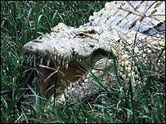
David George said two crocodiles stared at him every night

David George, 53, said that he had no choice. He went into an area in Australia with lots of crocodiles, and because of his problems he could not escape on foot.
He only had two meat sandwiches, and crocodiles moved and waited under his tree each night until the rescue. They knew he was there, they were waiting for him.
His problems began when he fell off his horse in the desert.
He was hurt and dizzy, but he managed to climb back on his horse and hoped to get home. But the horse went the wrong way and soon he saw that he was in an area full of crocodiles. In fact he was so shocked that he fell off his horse, into a crocodile’s nest. The adult crocodiles were away, but they never go far from the nest. It was a desperate situation.
I knew the safest thing was to stay and wait
David George
"I couldn't go back home, it was too far and too dangerous, so I went to the nearest high ground and stayed there. I was hoping that people could find me."
'Red eyes'
Mr George, manager of the Silver Plains Farm near Coen in north Queensland's, said two crocodiles stayed at the bottom of the tree every night and stared at him.
"I saw red eyes below me and I was very scared”, he said. Mr George decided it was safer to stay in the tree.
Mr George ate his sandwiches in three days, but he had water in the day. He knew people were searching for him because he saw helicopters flying above the tree.
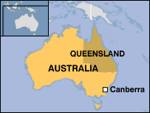
Then they came. They gave him a chocolate bar, and he said “it was like a gourmet meal."

Now answer these questions:

- Why did he climb the tree?

- Why couldn’t he get down?

- Why was he in this dangerous area in the first place?

- Why didn’t he just leave and go home?

- Where did he fall and what was the biggest problem with this?

- What was the main problem when he was in the tree?

- What other problems did he have?

- What gave him hope?

- How do you think he felt after four days in the tree?

- What was his first meal after his rescue, and how did he describe it? What do you think this means?

Now think of a different way to say these things:

Example:

- He could not escape on foot

It was impossible to escape on foot

- Two crocodiles stared at him

- I was very scared

- It was safer to stay in the tree

Now think of four questions you can ask this man:

Example:

How did you feel when you arrived home and saw your family again?

